**Weekly Contribution – 14/03/21**

**Name: Wasif Hossain**

**Student ID: 13227640**

**Trello**

Set up Trello and worked on majority of the Trello Cards by making them into user story formats.

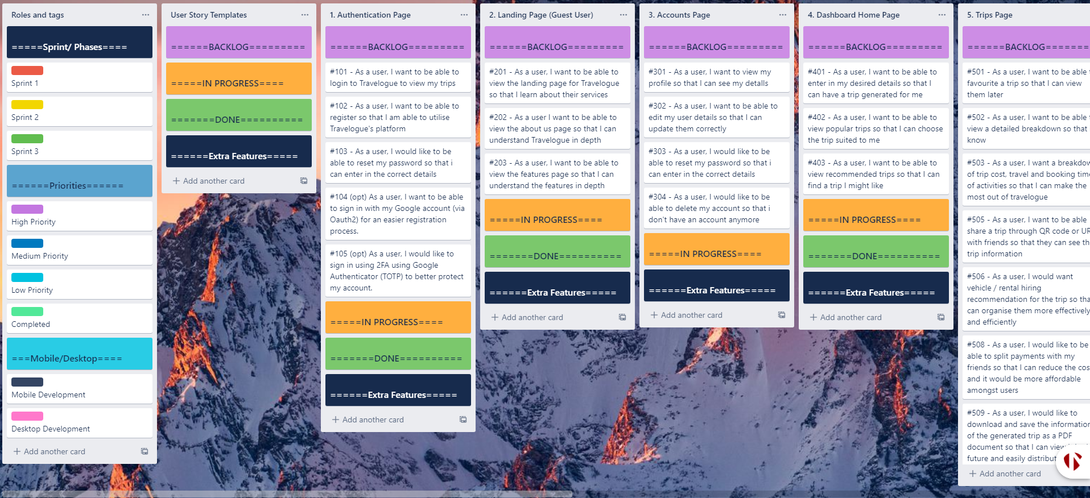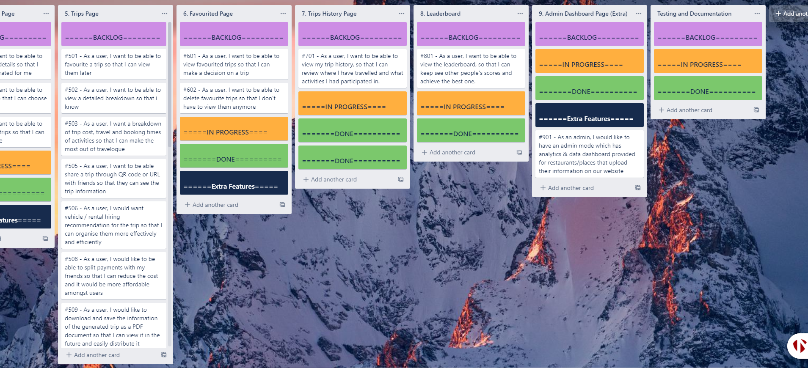

**GitHub Setup**

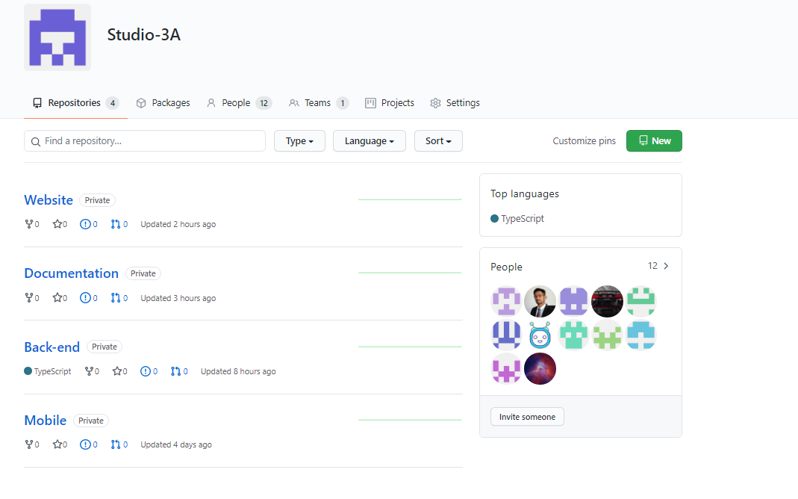Configured GitHub and created repositories.

**User Story Map**

Created the user story map from the Trello cards and allocated according to sprints.

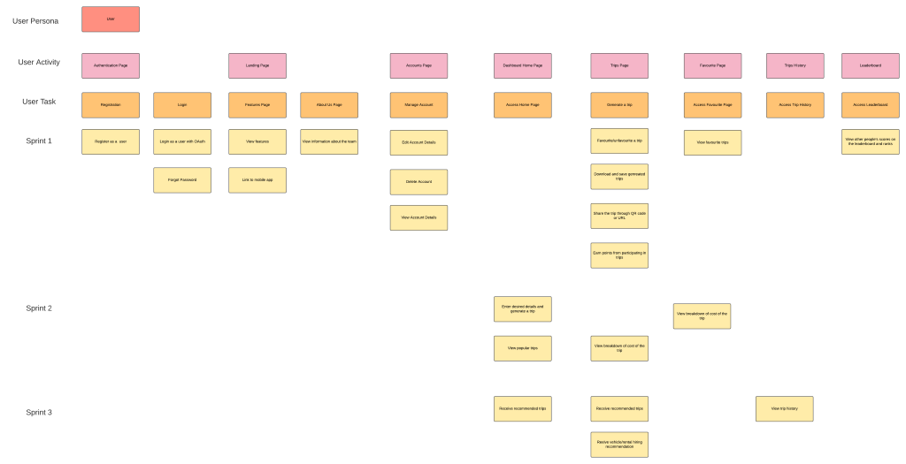

**Team Charter Contribution**

In the team charter I contributed to the following sections such as:

* Project Scope
* Definition of Done
* Team Information
* Project Timeline
* Risks
* Functionality composition

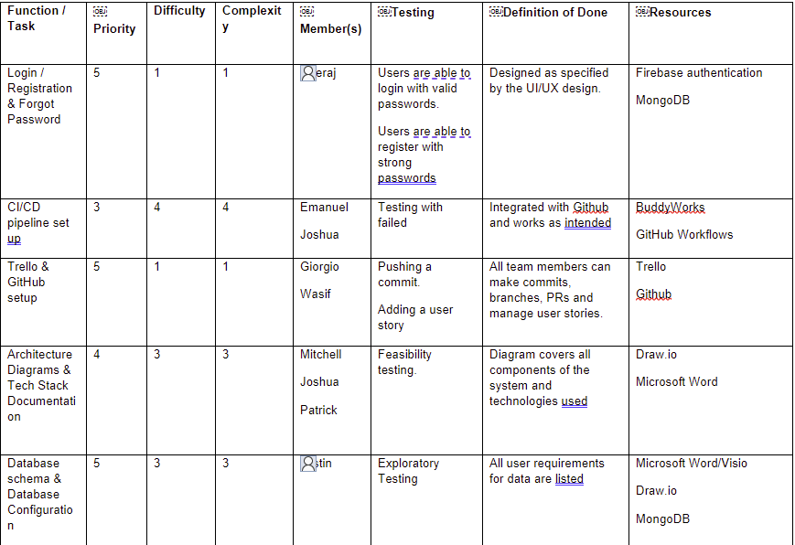

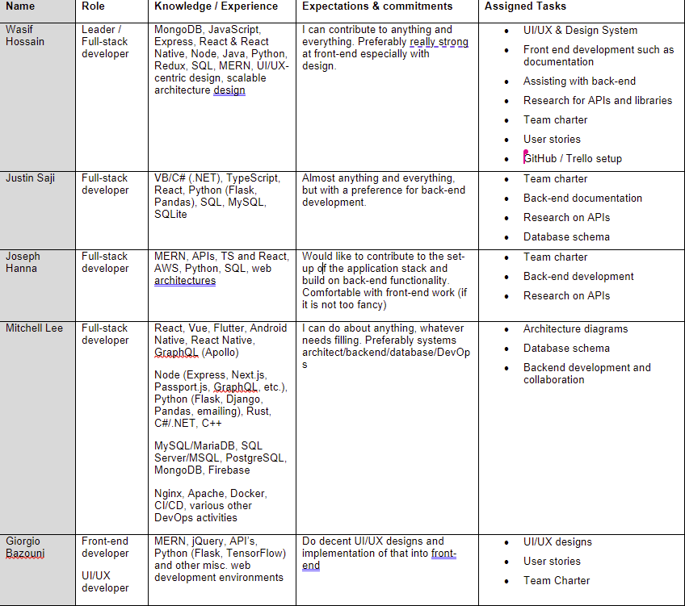

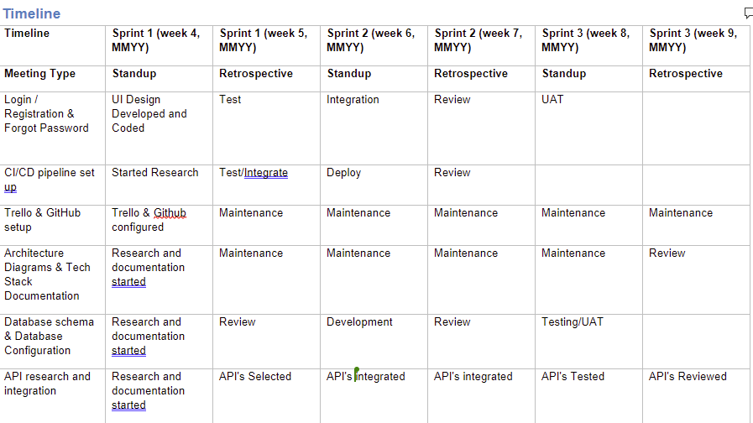

|  |  |  |  |  |
| --- | --- | --- | --- | --- |
| **Risk Summary** | **Risk Detail** | **Impact** | ￼**Probability** | **Mitigation** |
| Team member is overworked | Due to the busy schedules of the team, a member might be overloaded with work for one sprint. | The system might be delivered late if tasks are of a high priority and might deliver a low-quality product. | 4 | The team communicates their workload at weekly team meetings, and voices when they need assistance. |
| Lack of knowledge and skills | Team may struggle with completing tasks due to a lack of knowledge and skills as they have low exposure of using deep technologies and concepts especially around microservices and machine learning | Project requirements would not be met according to the specified standards | 2 | Team will need to be flexible in these circumstances, simplifying the requirement and learn or research on these deep technologies. It could be facilitated by developing documentation and collaborating with other team members who may be more experienced. |
| Data breach | Data can be read by unauthorised users | Data would be vulnerable, and this could result in a breach of privacy | 3 | Data must be handled securely by using industry standard encryption methods and enabling IAM for the database to increase security. |
| Testing does not cover all newly built functions or misses critical bugs | Tester fails to test specific functions of the system and inadvertently allows bugs to build and develop. | Bugs and errors would be produced whilst using the application resulting in a very poor user experience. This would also cause functions / features to work unintentionally, delaying the progress and productivity of the team. | 4 | Testers would need to inform of the expected output of the feature/ function and would need to be more comprehensive on their documentation and testing. There could also be the integration of automation testing scripts through CI/CD preventing runtime errors from occurring and a dedicated DevOps team would also ensure that testing practices and standards have been met. |
| Misinterpret Requirements | When designing the program, developers may misinterpret the technical requirements which were set by the product owner | This would reduce productivity as aspects of the product would need to be reworked. It would also increase costs in terms of time, as deadlines would need to be postponed. | 4 | Having regular discussions and meetings and asking questions or feedback to clear up misinterpretations. |
| Loss of data | Mishandling software / database can lead to a loss in data | Data loss would mean users are unable to view their details and would result in possibly incorrect details being displayed to other users | 2 | Measures can be taken such as mitigating the task specifically to the data/machine learning team and back-end team. Would also need to identify and prevent specific sections of software from resulting in data loss and can also find ways of backing up important data. |
| Communication | Team being unable to physically meet, the team may communicate ineffectively | Improper communication can cause development efforts to be misdirected and reduce productivity of the project and progress. | 2 | Team members have all made commitments to showing up a certain number of weeks throughout the semester. |
| Management | Overlapping or missing tasks | Through lack or miscommunication more than one person may be assigned to a task or tasks may be left incomplete. | 2 | Through use of team meetings as well as scrum meetings it ensures that work assigned is clearly allocated and understood |
| Testing | Tester does not cover all newly built functions or misses critical functions due to our application have many features and functionalities | Easily fixed bugs are allowed into the main build of the program then other features are built on top of the bugs and therefore produce incorrect functionality at the end. | 2 | Testers must be thorough throughout the process testing at regular intervals and checking connections between new and existing functions. With the setup of our CI/CD pipeline, bugs will not be merged with master, along with the setup of automation testing, this risk is minimized. |
| Team | Insufficient testing time | Large issues with functionality could potentially be overlooked, resulting in a final product that fails to operate properly. | 2 | Ensure that every team member is responsible for testing efforts in every sprint. |
| System Functionality | Consistency between software used | Different software when used together can cause additional bugs and defects.  Creates added difficulty to debug and may cause loss of some parts of the system. | 2 | Team members must use same or similar software to decrease risk of bugs caused by collaboration as decided in the team charter. |

**Definition of Done for Product**

The definition of done is a shared understanding of what it means for work to be completed. To deliver a high-quality product, the team would need to agree on a list of criteria which must be met at the end of each sprint before the product progresses. The following checklist enables the team to verify that all the core features have been fulfilled according to their original assumptions and that if all required conditions are met, the product would deploy successfully. These include the following core features which are in the form of a user story such as:

* Login, registration and reset password pages, making use of OAuth2
* Landing page which showcase Travelogue’s features and an About page for the team
* Edit profile details and update them, reset password and also delete account
* Trip page which takes user inputs and generates a trip and shows popular trips
* Generated trips which include user inputs such as budget, number of friends, location, distance and show a cost breakdown of the trip and available booking times
* Recommendation for trips based on user’s recent activity and preferences
* Receive points for participating in events and activities
* Leaderboard to view other users’ points
* Favorite trips and being able to share trips through QR code or URL
* Remove favorited trips
* Downloading trip information as a PDF
* Vehicle / rental hiring recommendation throughout the trip
* View trip history in order to review places that have been recently travelled

**Project Scope & Benefit**

We, a team of software engineers at UTS, have been formed to develop an application that will generate trips based on essential factors such as budget, time, location, number of individuals, date & time, and mood. The purpose of the application is to provide a service which saves time & money and reduces the hassle of coordinating a trip between a group of individuals.

Existing electronic travel-booking solutions do not provide travelers with a one-stop solution for all their traveling needs. Travelers are currently restrained by what they can do in a single application, usually limited to just booking accommodation and finding general information about various areas they plan to stay in. They are unable to plan where to eat, what activities to do, and estimate costs for the entire trip all at once. We plan to overcome this pain-point and add convenience by providing a mobile and web application service that does exactly this, revolutionizing what it means to provide an electronic travelling assistant.

**User Interface / Experience**

**Design System**

Created and worked on the whole design system/documentation which is show with the screenshots below:

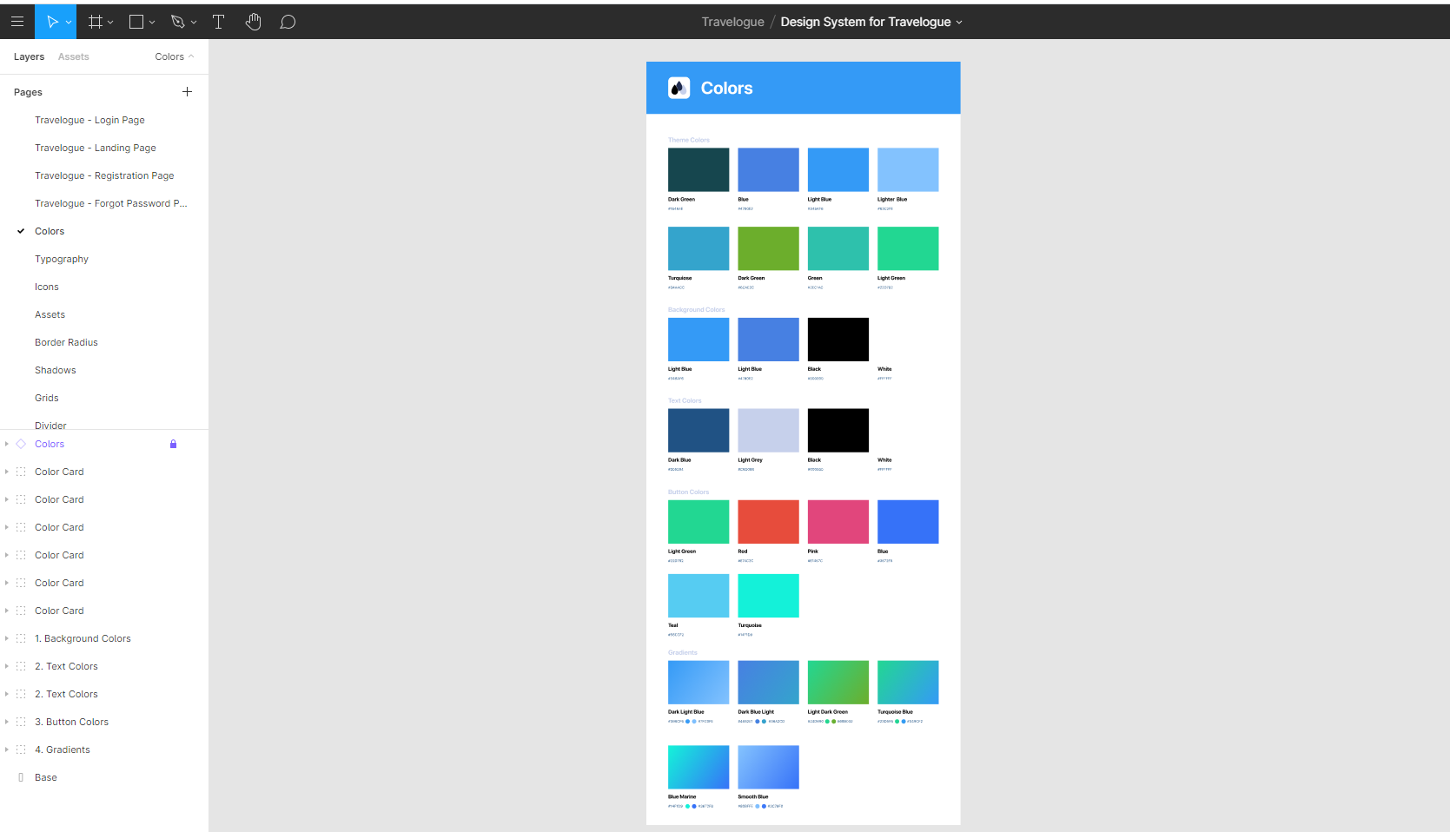

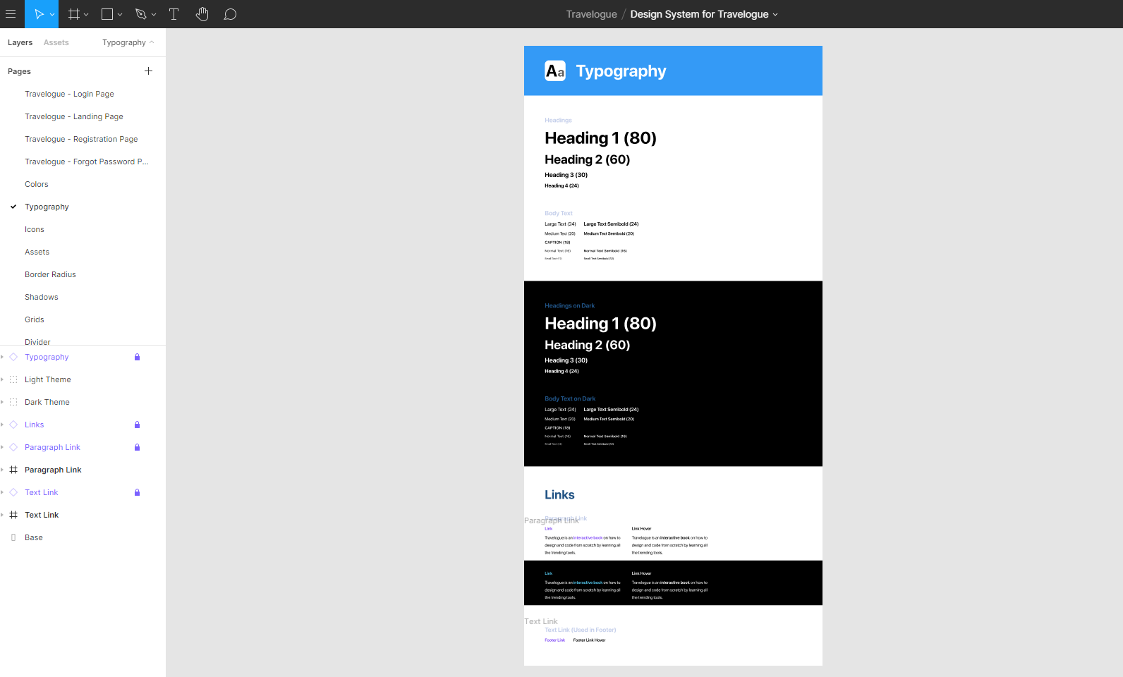

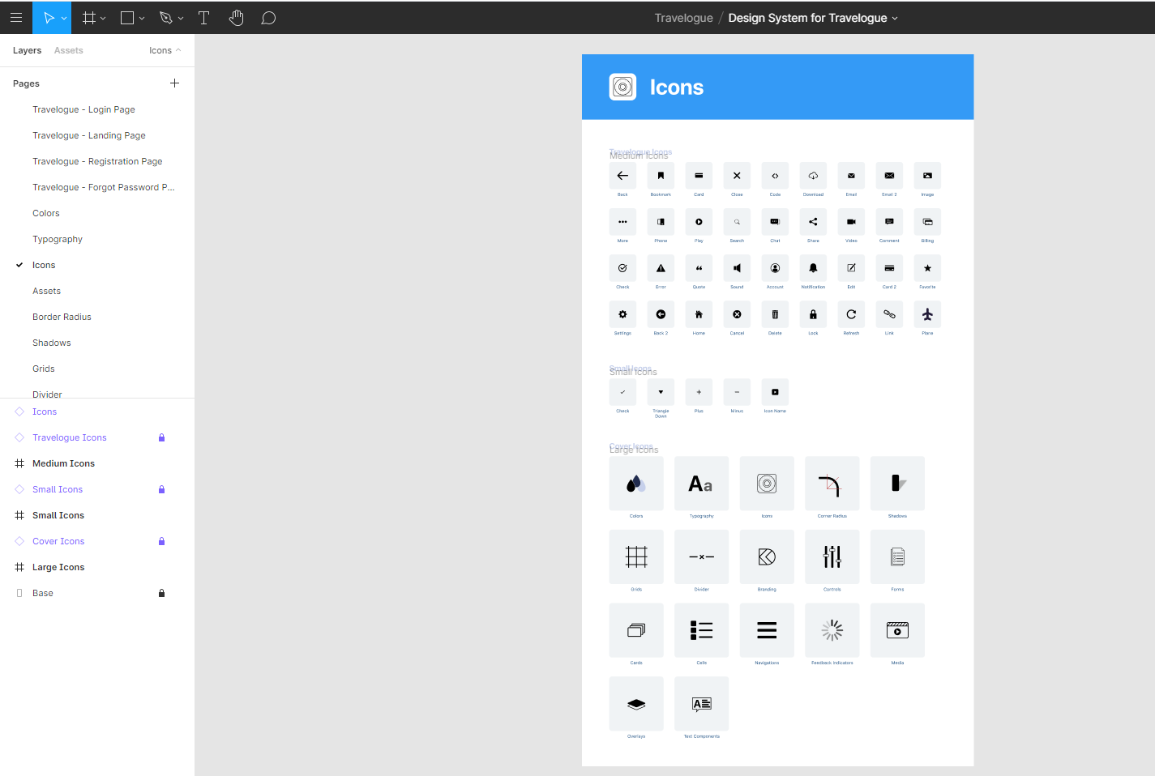 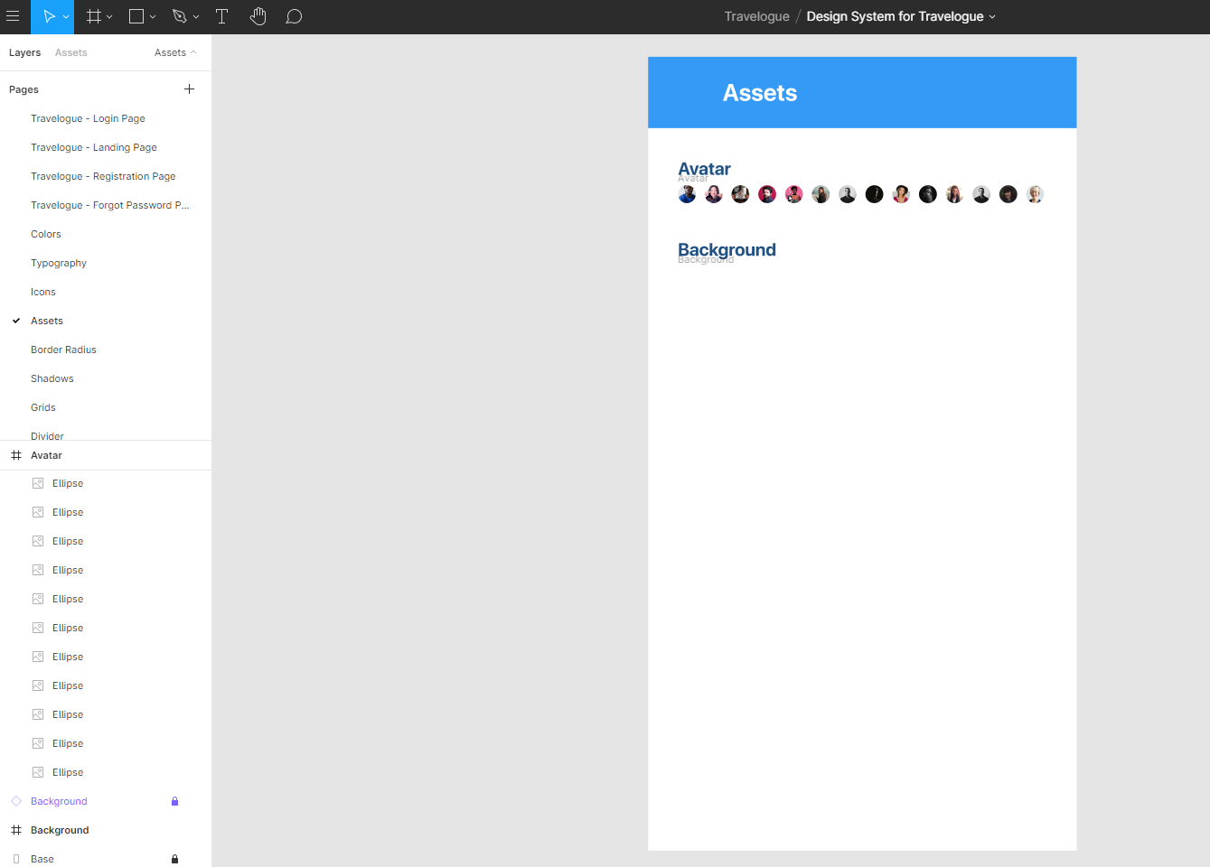 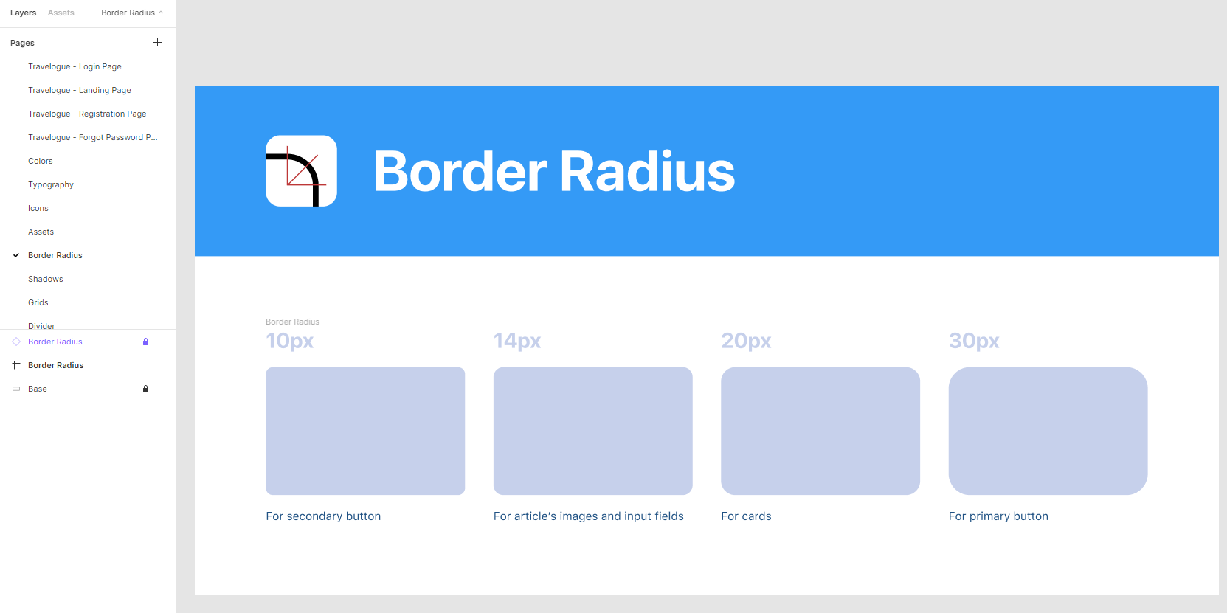 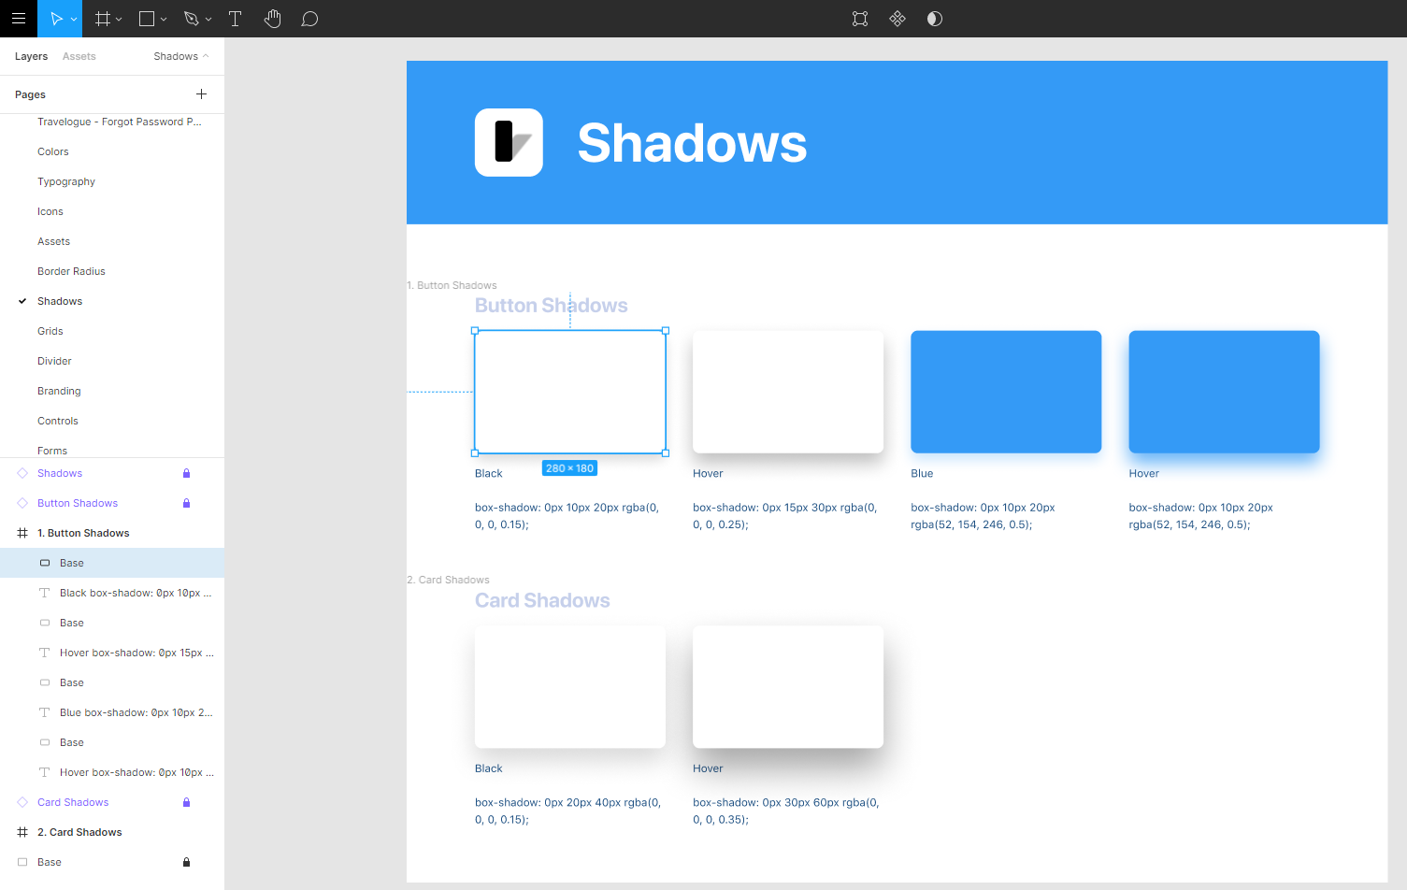 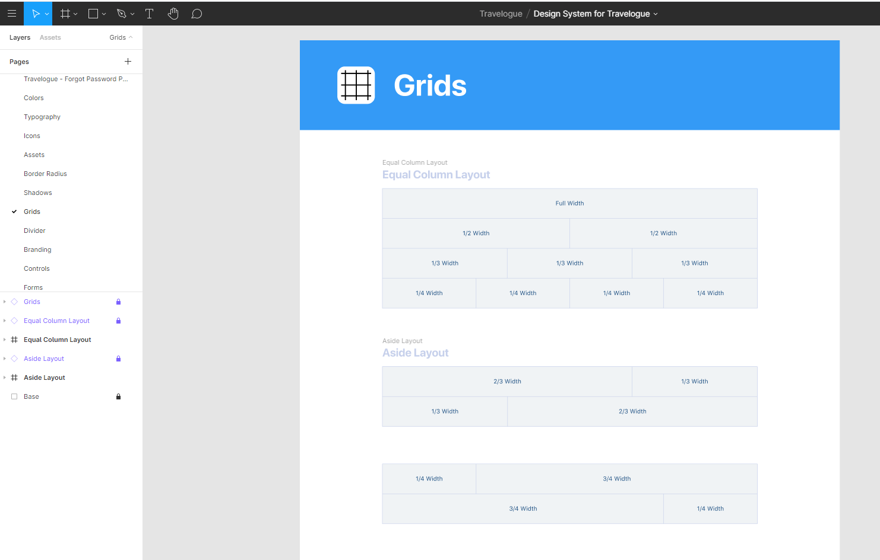 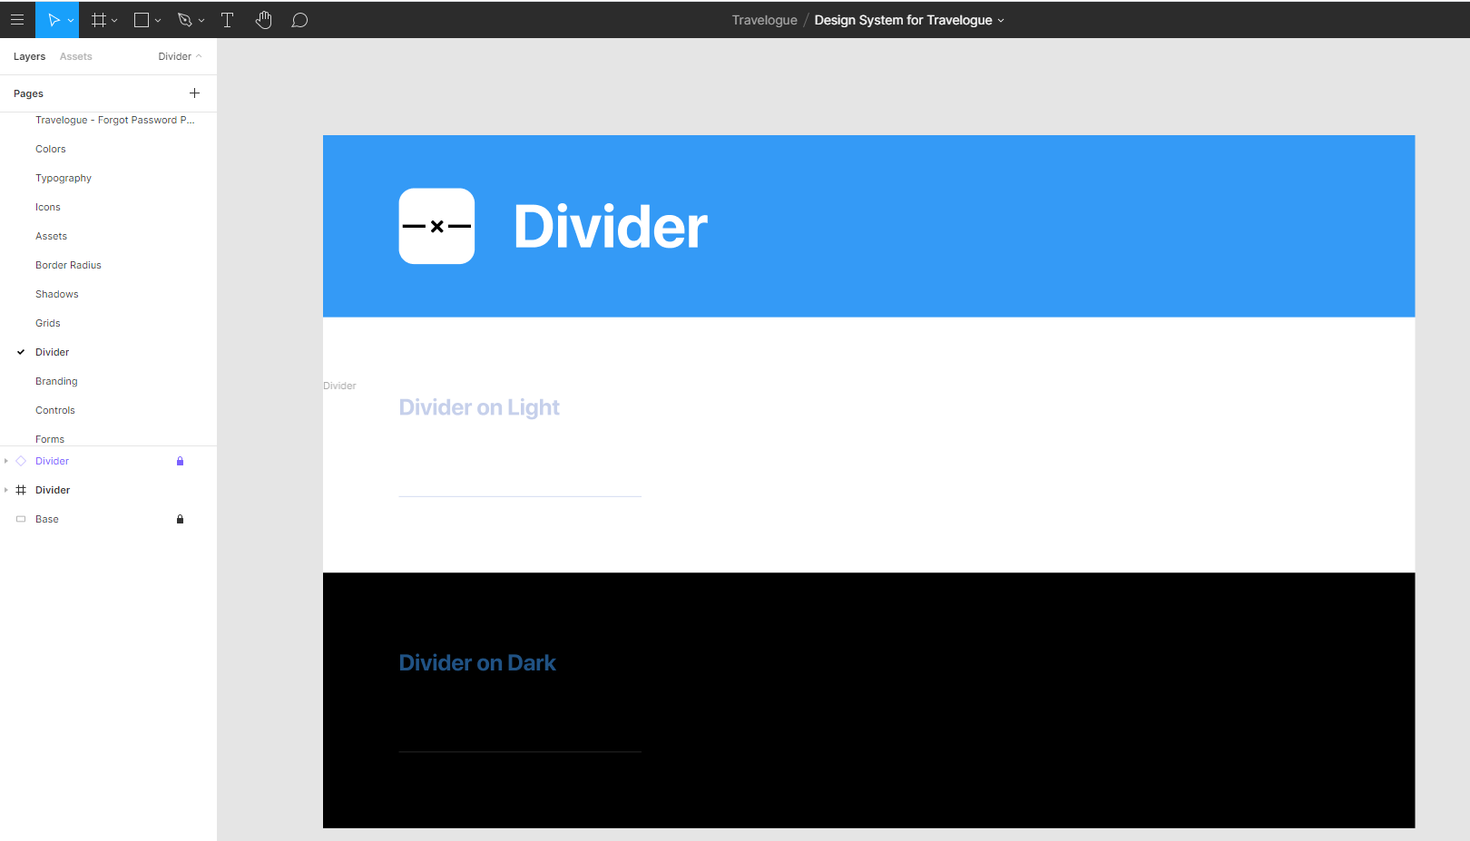 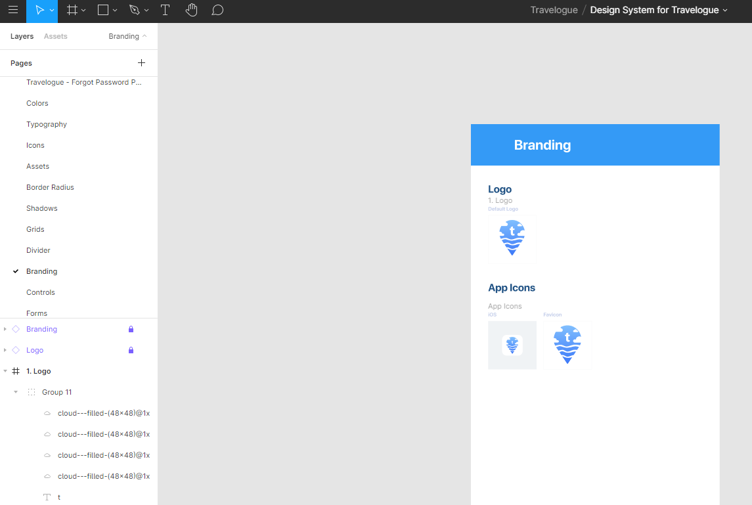 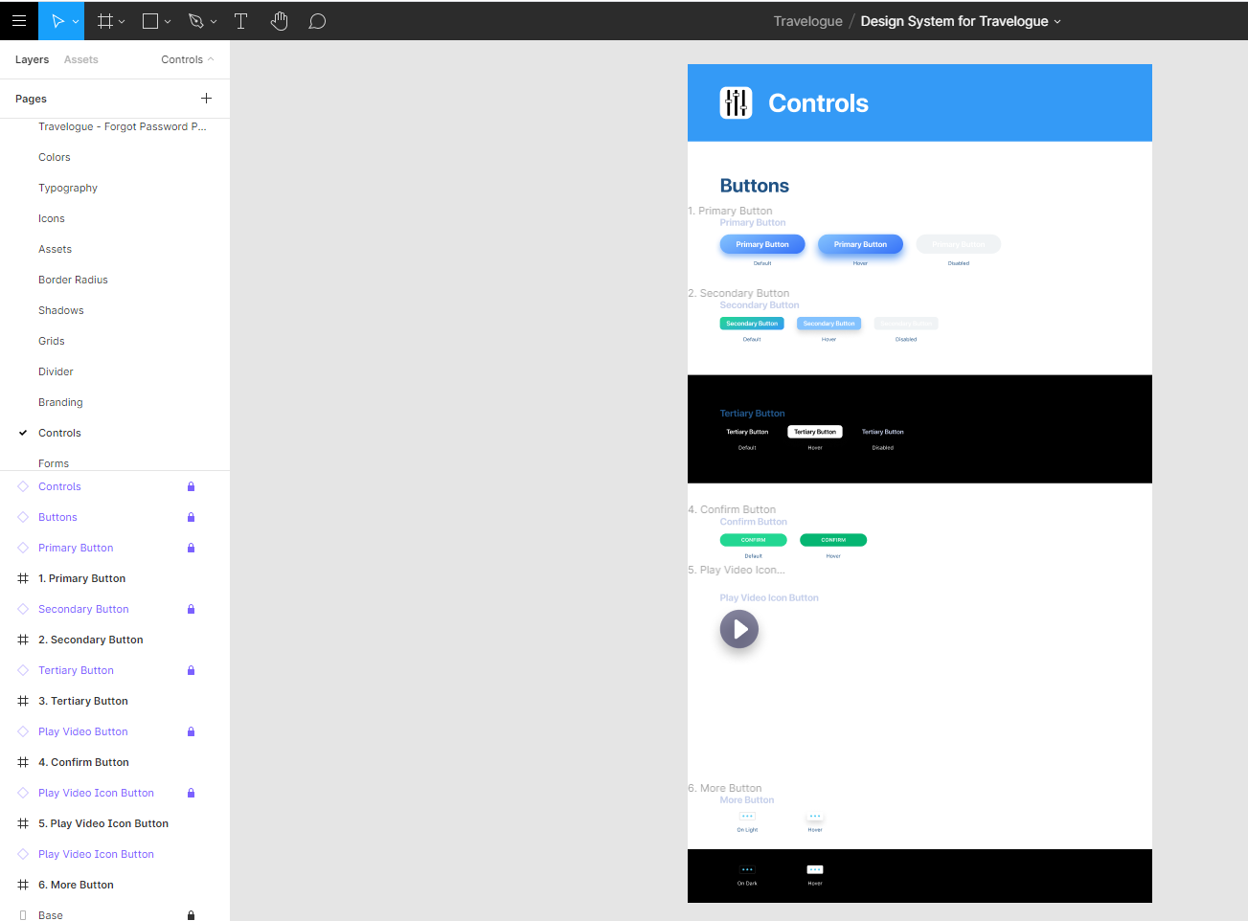 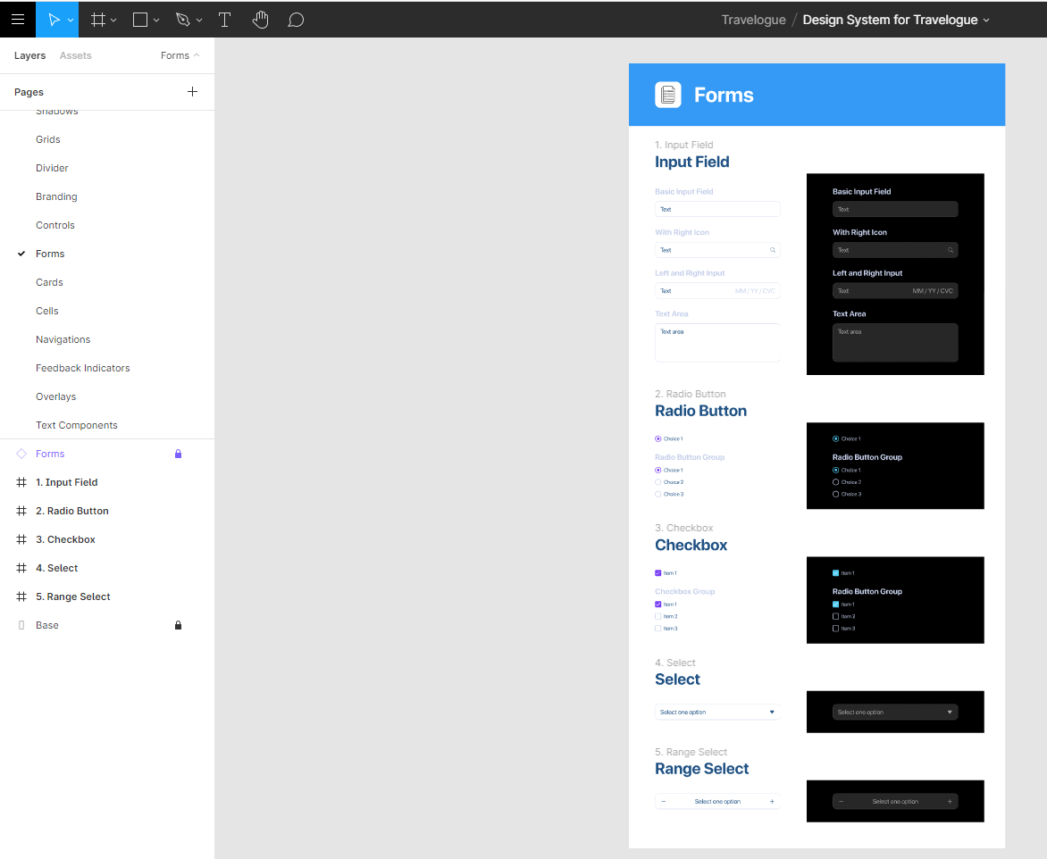 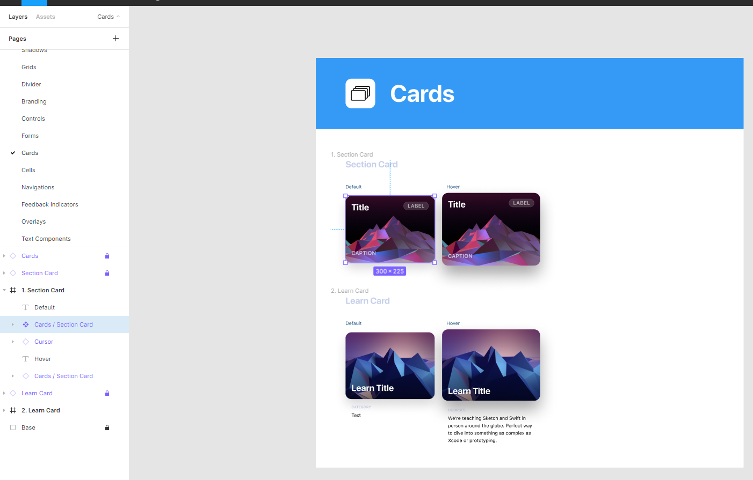 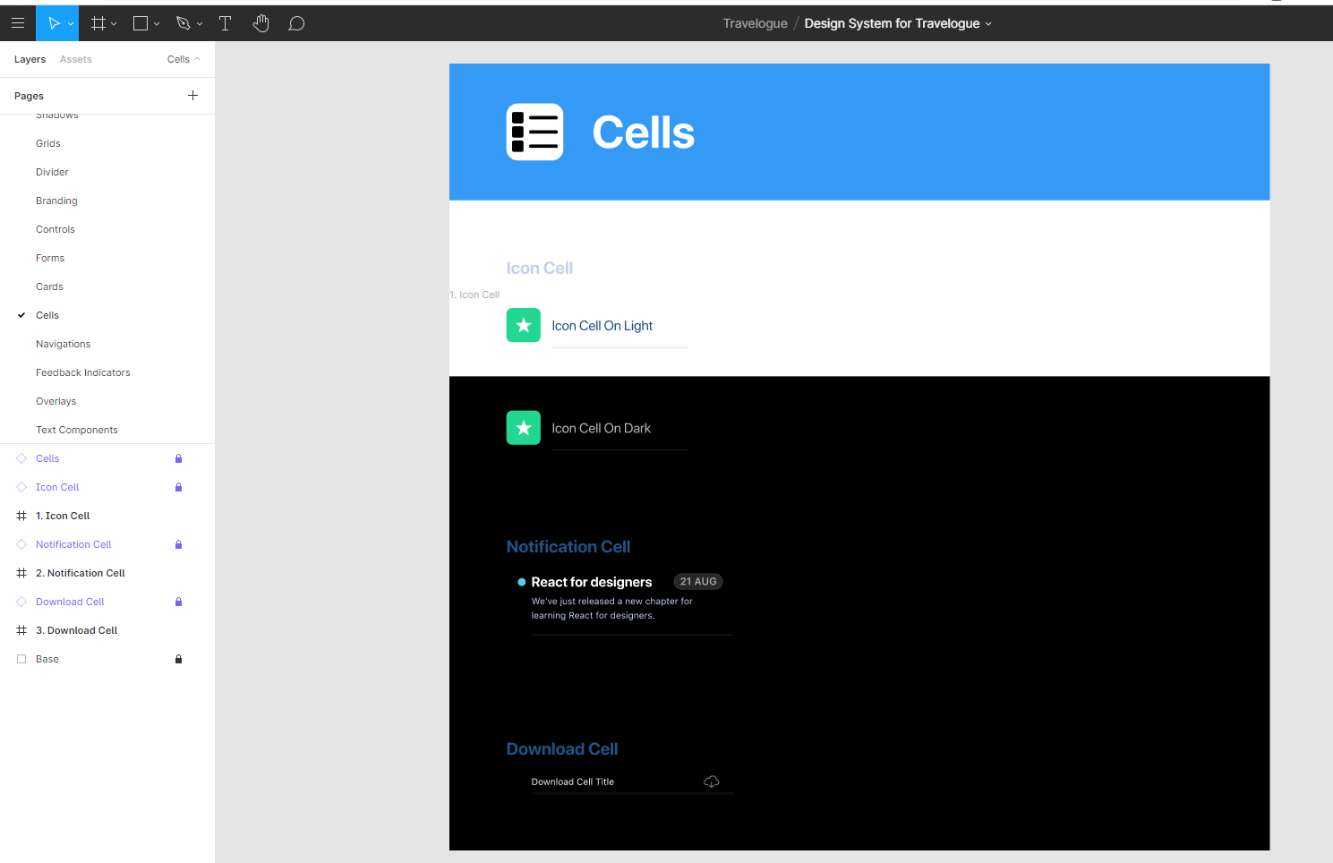 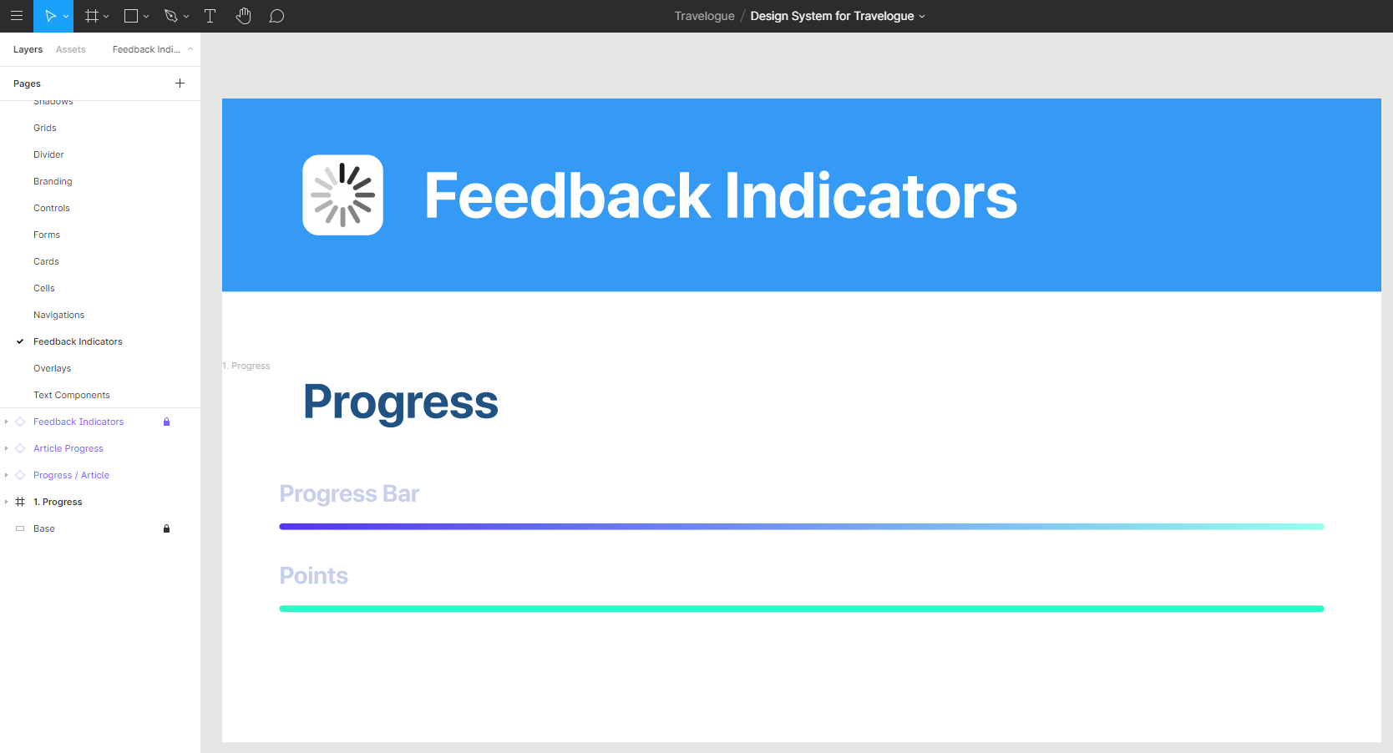 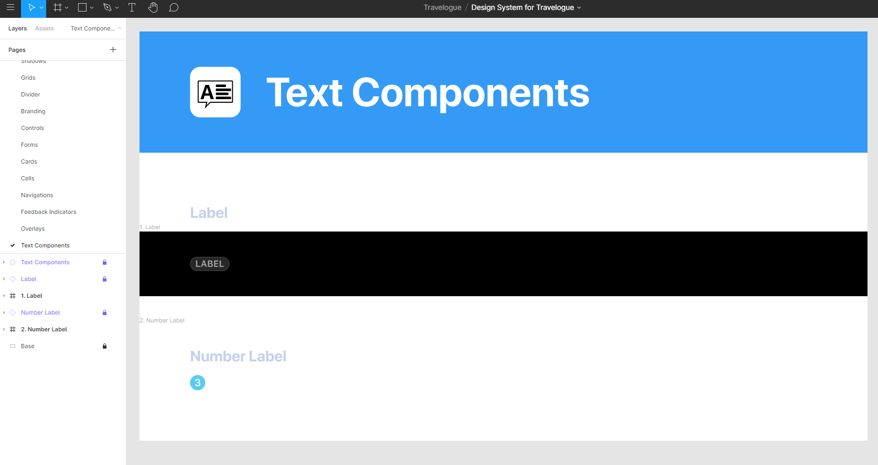

**Logo Iterations/ Designs**

Created and worked on several logo iterations and designs with 9 icons shown below.

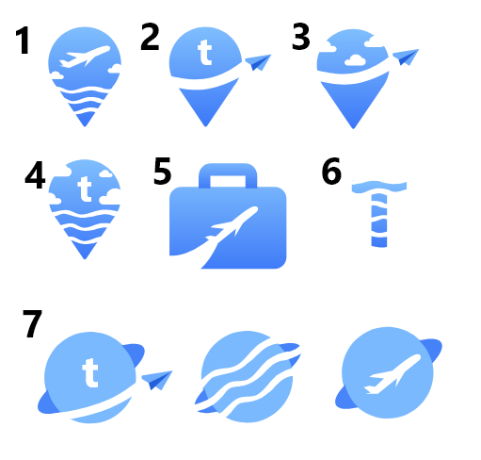

**Landing Page**

Created and worked on the Landing Page which is still working in progress and assisted Giorgio on authentication page such as login, registration and forgot password.

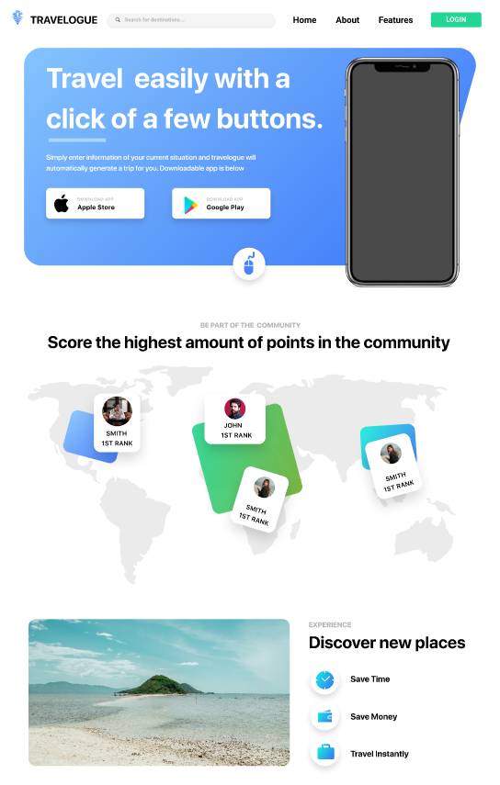

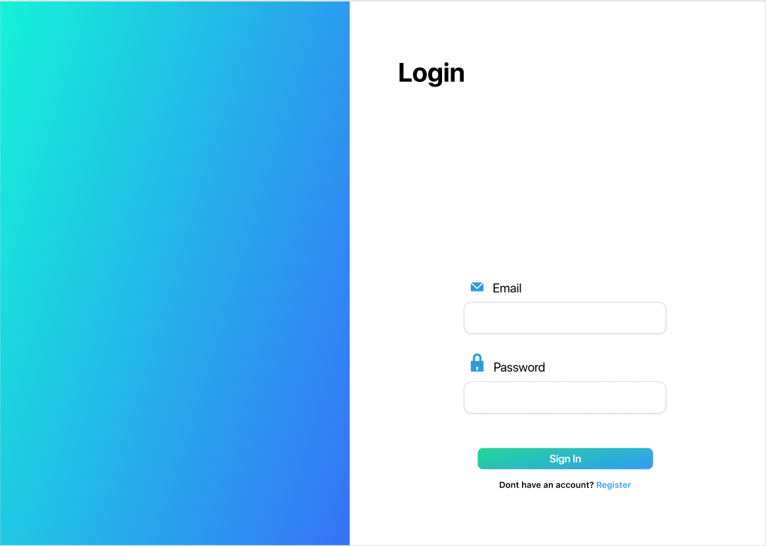

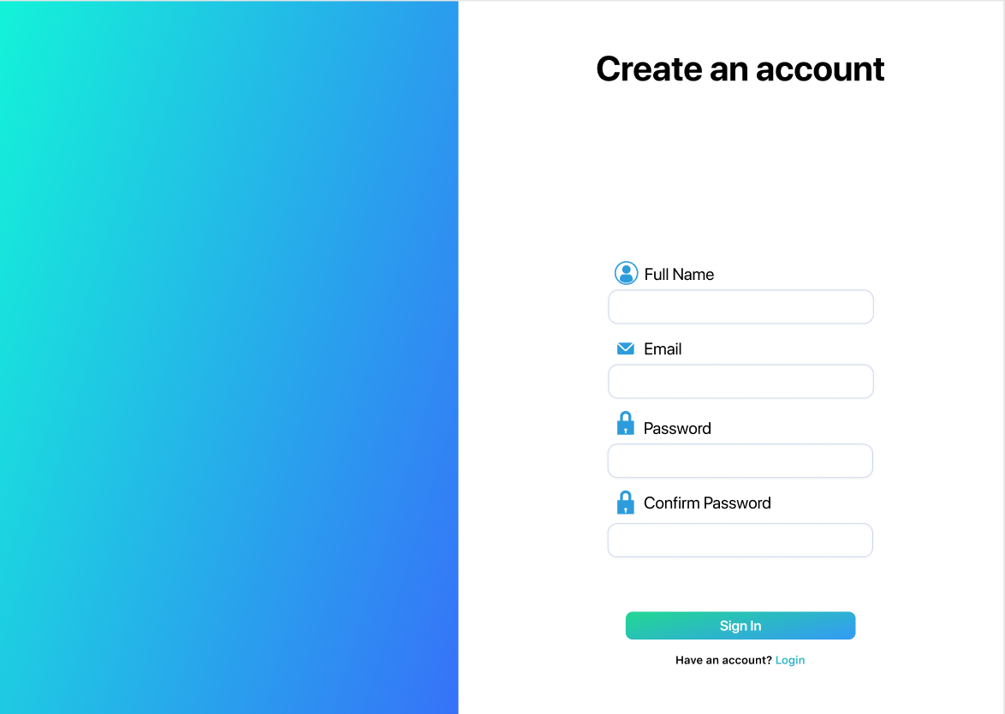

**Development Research**

Studied front end development such as React Node and made some notes for the team which has been uploaded as a commit with a hash of: 2b13a63d5c11135d16fde1abffe7c9f5dd0643d9

**Commit URL**: https://github.com/Studio-3A/Website/commit/2b13a63d5c11135d16fde1abffe7c9f5dd0643d9

